9th Kup Yellow Strip Revision Sheet

Yellow Belt means:
Signifies the earth from which a plant sprouts and takes root as Tae Kwon-Do foundation is being laid.

Practical:
Basics from previous Grading’s
Pattern Chon-Ji
Sitting Stance 10 Double Punches
Walking Ready Stance & Front Snap Kick
Walking Stance Double Punch
Walking Stance Low Block & Rising Block
L Stance Middle Block
L Stance Knife Hand Strike

Chon-Ji:

Chon-Ji literally means the “Heaven and Earth”. It is in the Orient interpreted as the
creation of the world or the beginning of human history. Therefore it is the initial
pattern performed by the beginner. The pattern consists of two similar parts one to
represent the “Heaven” and the other the “Earth”. 19 moves.

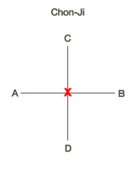
Terminology:
Pattern Tul
L Stance Niunja Sogi
Rising Block Chookyo Makgi
Double Punch Ibo Jirugi
Ball of the Foot Ap Kumchi
Foot Sword Balkal
Turning Kick Dollyo Chagi
Side Kick Yop Chagi
Obverse Baro
Reverse Bandae
Step Turn Omgyo Didimyo Dolgi
Knife Hand Side Strike Sonkal Yop Taerigi

